**e-ISSN: 3027-0650**

**Vol. 2, Issue 1, pp. 379-389, November 6-9, 2024**

**FLOOD LEVEL MAPPING FROM DIGITAL ELEVATION MODEL (DEM) THROUGH REMOTE SENSING/GIS IN YOLA CATCHMENT AREA, NORTHERN UPPER BENUE TROUGH, NIGERIA**

**Sebastian Abraham Sunu1,2*\**, Lucky Peter Kenda3, Adetola Sunday Oniku2, Meludu Chukwudi Osita2, Abbey, Chukwuemeka Patrick1, Joseph Aza Ahile2, Charles Chinedu Uwaezuoke1 & Kwarki Simon4**

*1, 2Department of Petroleum Chemistry & Physics American University of Nigeria (AUN) Yola*

*2 Department of Physics, Modibbo Adama University, Yola, Adamawa State, Nigeria*

*3Department of Physics, Taraba State University, Jalingo*

*4Department of Physics Education Federal College of Education (Tech) Gombe, Gombe State*

*\*Corresponding author E-mail: abraham.sebastian@aun.edu.ng*

**Abstract**

Yola catchment has recently experienced extreme climatic conditions attributed to climate change, leading to a substantial increase in rainfall intensity and, consequently, more frequent flooding in the region. Effective management of such disasters can be achieved through the utilization of precise datasets, such as Digital Elevation Models (DEMs), to delineate flood levels. DEMs are preferred due to their accessibility and lower computational demands in modeling applications. The topographic data derived from DEMs serve as crucial input parameters for comprehensive flood level mapping. Methods based on DEMs facilitate the identification of areas that are geomorphologically susceptible to flooding. In this study, DEM-based techniques were utilized to delineate areas that are susceptible to flooding due to their geomorphological characteristics. DEM data from SRTM satellite imagery were processed using Arcgis10.6 to categorize flood level areas according to the terrain and landform characteristics of the study area. The DEM classified flood levels into two categories were imported into ArcGIS 10.6 and reclassified. The analysis revealed two classifications of flood levels: the most floodable areas, which constitute 33.3% of the study area and cover 170.6 km², impacting nine villages, and the less floodable areas, which account for 25.41% of the study area, covering 130.1 km² and affecting twenty villages. This flood level mapping is intended to enhance awareness among residents, prioritize land development, and improve emergency preparedness, including aid and relief operations in areas at high risk of flooding in the future.

**Key words:** Flood level, DEM, Flooding,GIS

**1. Introduction**

Floods are one of the most common widespread, instantaneous, severe, frequent, and devastating natural hazards. They pose threats to human lives and the environment and cause severe economic damage in different regions of the world (Sun et al 2020; Daniel, 2016; Khan et al, 2011; Karki, et al, 2011; Bajabaa et al. 2014; Elnazer et al. 2017; McCarthy, 2001). In addition to being a natural geophysical hazard, it is a potentially harmful physical phenomenon that may result in loss of life, injury, disease, collateral damage, economic hardship, and environmental degradation (Du et al. 2013; Youssef et al. 2011; UNISDR, 2004). Floods have been the most common type of geophysical disasters, and is largely a localized event caused by extremely heavy torrential rainfall that may last for few minutes/hours or days, weeks, or longer resulting in the overflow of the natural river banks (Brammer, 1990; Kamal et al. 2018), Other hazards associated with floods include landslides, mud flows, violent convection storms, water contamination, prolonging surface runoff, and ecological impacts (Collier 2007). As a result of global climate change, flood intensity and frequency are expected to increase tremendously in the future (Jonkman & Dawson 2012; Adnan & Kreibich, 2016; Field et al, 2012; Rahman et al. 2019). Flood forecasting is always difficult to predict due to lack of real time data. The incidence of flood events has been attributed to climate change, rapid urbanization, rise in sea level, high population density, land degradation by pollutants, modified and intensified land use (Clark, 1998).

Therefore, flood is a natural phenomenon that persistently overflows large volume of water that occur due to (extreme hydrological runoff event) prolonged heavy rainfall, rapid accumulation and release of runoffs and overflow of this water flashing beyond its normal confines (Leopold et al, 2012). According to WHO (2003), flooding affects 140 million people annually on average and can have devastating and severe effects on many countries around the world. Examples include the 1959 floods in China and the 1974, 1987, 1988, and 1998 floods in Bangladesh, the annual flooding in southern Bandung, Indonesia, and the December 2004 tsunami in Southeast Asia, as well as settlements around the Mississippi River in the United States. (Ahem *et al.* 2005). Africa has had devastating floods in recent years in places including Burundi, Djibouti, Kenya, Rwanda, Morocco, Somalia, and Uganda. According to statistical data, floods cause 34% of all natural disasters worldwide in terms of number and 40% of losses (Lyu et al., 2019; Petit-Boix et al., 2017; Yalcin & Akyurek, 2004). Flooding poses a threat to more than one-third of the world's geographical area and can impact up to 82% of the global population. Over 90 nations and 196 million people are at risk of catastrophic flooding (Karki et al., 2011).

Nigeria is therefore not an exception to nations that have recently suffered from the destructive consequences of flooding. Approximately 431 people died and an estimated 1.3 million people were displaced in 2012. in addition, 1525km2 of farmland were submerged from thirteen states MISNA, 2012). States in Nigeria such as Adamawa, Taraba, Benue, Kaduna, Kano, Sokoto, Bayelsa, Bauchi, Nasarawa, Niger, Kogi, Edo, and Anambra States are the most vulnerable states due to flooding have also experienced the devastating effects of flood annually (FGN, EU UN 2012). According to the Adamawa State Emergency Management Agency (SEMA), different levels of damage have been reported in several sites within the northeastern Nigerian state of Adamawa as well as other parts of the nation since the start of the rainy season (Table 1). Significant damage has been done to shelters, farmlands, and infrastructure due to heavy rains and severe winds (IOM, 2022). The previous few decades have seen floods in a number of riverine villages. Since August 2022, the state's central region has been mostly affected by high rains and flooding, which worsened in October 2022 and cost 173,049 people in 11 local council areas their property, crops, and cattle. Along the river banks, more than 19,000 people were temporarily relocated from 149 settlements spread over seven local council regions. Fifteen individuals were killed and 19 more were reported missing. When water from Cameroon's Lagdo Dam was released in October 2022, the upstream flow of water from the country's highlands caused the Benue River to burst its banks and flood nearby settlements. Flood disasters' spatial distribution in central Nigeria was mapped by Ojigi et al. (2013). Identifying all sites that are susceptible to flooding is one method to lessen its effects. Flooding is mostly caused by river flooding and heavy rains. The Benue and Niger, Nigeria's two main rivers, spilled their banks, submerging nearby farms and communities. The main causes of floods are heavy rainfall and river flooding. Intense flooding resulted from the two main rivers in Nigeria, the Benue and Niger, overflowing their banks flooding farmlands and communities along the flood plains. Areas (depth and extent) that may be at danger of flooding under conditions of excessive rainfall are identified by flood level mapping, which is a crucial component of suitable land use planning and effective management of future flooding occurrences in flood-prone areas. Administrators and planners can more quickly identify danger regions and prioritize their mitigation efforts because to the charts and maps it produces, which are quick and easy to read (Meyer et al. 2001). In-depth knowledge of flooding in these areas has not been established, and inadequate spatial coverage of hydrological databases makes it difficult to accurately forecast floods and manage flood risk. Despite the significant and devastating impact that floods have on the livelihoods of those who live in these areas, no effort has been made to identify areas most at risk of flooding or to delineate the boundaries of flood level at the community level. Thus, this study looks at and maps the flood level in Adamawa state's Yola catchment, which is situated in the River Benue's flood plains. According to Jonkman and Kelman (2005), Khan et al. (2011), and Dihn, Balica, Popescu, and Jonoski (2014), flood vulnerability is expected to increase in frequency and severity due to rapid urbanisation, climate change, and extreme weather conditions like heavy rains and river discharge conditions that endanger human life in various parts of the world. The current trend and future scenarios of flood risks necessitate the requirement for accurate geographical and temporal information and databases on potential hazards and flood risks. Emergency services and early warning systems must assess flood vulnerability in order to create management plans for the prevention and mitigation of future flood occurrences (Tehrany et al. 2015).

Numerous comprehensive tools, such as HAZUS, a GIS-based natural hazard analysis tool intended for assessing flood hazard, and HECFDA, a computer software that assists crop engineers with vulnerability analysis of flood risk reduction measures, are used by numerous research groups worldwide. According to Khan et al. (2008), Saha et al. (2005), Wang et al. (2013), and Pourghasemi et al. (2014), RS and GIS techniques offer a suitable platform for manipulating and evaluating the relevant information in order to create suitable hazard zones with ease. RS and GIS techniques are very helpful when evaluating flood damage caused by large rainfall in a catchment area or sea wave surges in coastal areas (Pradhan et al. 2014; Patel & Srivastava, 2013). Many research organisations around the world use a number of comprehensive tools, such as HECFDA, a computer program that helps crop engineers with vulnerability analysis of flood risk reduction policies, and HAZUS, a GIS-based natural hazard analysis tool designed for evaluating flood hazard. In order to easily demarcate appropriate hazard zones, RS and GIS approaches provide an appropriate platform for manipulating and analysing all pertinent information (Khan et al. 2008; Saha et al. 2005; Wang et al. 2013; Pourghasemi et al. 2014). When assessing flood damage produced by heavy rainfall in a catchment area or sea wave surges in coastal locations, RS and GIS approaches are extensively useful (Pradhan et al. 2014; Patel & Srivastava, 2013). Geographic information systems (GIS) have recently made a wide range of tools available for the quicker and less expensive creation of flood level maps, flood monitoring in flood-affected areas, and forecasting of areas that are expected to flood as a result of high river water levels. In order to determine flood levels, data from digital elevation models (DEM) was compiled using a geographic information system. In order to map the flood levels in a hydro basin, the Yola Catchment and the Northern Upper Benue trough watershed, DEM serves as a fundamental digital data collection. Digital elevation models have recently been used extensively in hydrological applications to help manage flood risk and flood level by storing and managing hydrological data and generating maps of flood inundation and hazards. These models are also used to determine the runoff response to rainfall (Garbrecht and Martz, 1996). In relation to any reference datum, the land surface elevation is represented digitally via a Digital Elevation Model (DEM). When referring to any digital representation of a topographic surface, the term DEM is commonly used. (Balasubramanian, 2017) DEM is the most basic type of digital topography represented. With DEM, a number of features pertaining to the surface hydrology of a certain location can be identified.

**2. Study area**

The research region is located in the upper Benue trough's Yola catchment, which runs east-west of the Yola Basin (Yola Arm). With a land area of roughly 511.966 km2, it is a section of the failed arm of a Cretaceous triple junction (Burke & Deway, 1973), which is located between latitudes 9o 5′ N – 9o 20′ N and longitudes 12o 25′ E – 12o 40′ E (Figure 1). The relief is primarily low-lying, ranging from below 110 m to 560 m on average. The River Benue cuts through the center of the research region and drains the hydrologic basin. The area is characterized by erosional and flood plains with several stream channels, and it is situated in the upper Benue trough catchment of the Yola arm. Seasonal flooding causes these erosional plains and floods, which are naturally rich in organic nutrients that are deposited there as flood water recedes. Seasonally, large amounts of sediment are deposited, particularly during floods, and are carried into the floodplains to aid in restoring the fertility of the soil. The research region is located in Nigeria's Sudan savannah, a semi-arid climate zone in Sub-Saharan Africa. It has two distinct seasons: a cold, rainy season which is from April to October and a hot, dry season starting November to April (Sebastian & Adetola, 2022).

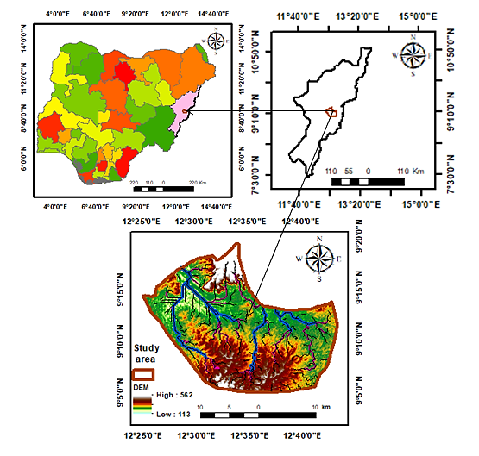

**Fig. 1.** Location Map of Yola Catchment area

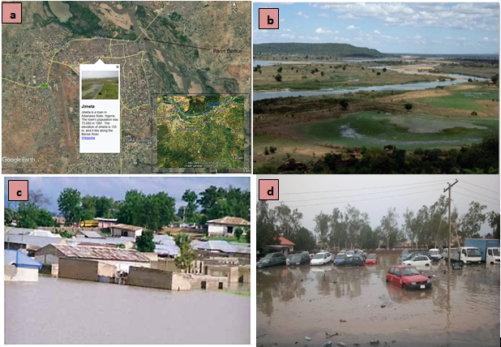

**Fig. 2 (a)** Figure 2 Shows Google Earth satellite imagery showing an investigated stretch of River Benue located along Jimeta in the Yola catchment area. **(b)** River Benue **(c and d)** How heavy rain caused havoc in Yola, Adamawa capital Published on May 17, 2019, Published on May 17, 2019 Jim [Ochetenwu](http://word/https://dailypost.ng/author/jim-ochetenwu/)

**Table 1** *Source*: Estimation by the Assessment Team on the basis of official information. 2012

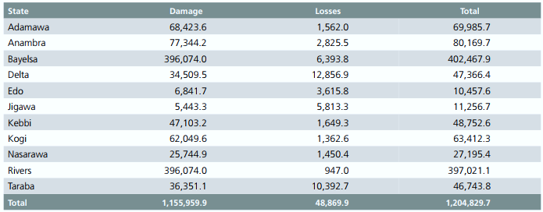

### 3.0 Materials and method

**3.1 Processed SRTM Data Version 4.1**

In order to accomplish the study's goals, we analyzed the DEM using a combination of remote sensing and GIS methods. The information was taken from the NASA/USGS SRTM data. Reuter et al.'s interpolation algorithms have been used to fill in the gaps in the original SRTM data. 2007 To create a drainage pattern and digitize the study watershed, the Shuttle Radar Topography Mission's digital elevation model was utilized. To create stream networks and define the watershed, a number of methods were employed. The morphological features of the basin were examined using the Arc GIS 10.6 program.

**3.2 Digital Elevation Model (DEM)**

A satellite data collection called the Digital Elevation Model (DEM) provides three-dimensional (3D) elevation information of the earth's surface. Digital surface models (DEM) are separated into two categories: digital surface model (DSM) and or the digital terrain model (DTM).

DSM is the elevation which is considered the height of all things including plants, buildings and so on, while DTM will consider only the bare ground at a certain area. General information of the earth’s surface can be obtained or information of a specific area on the points that has been set on the e earth’s surface (Jarvis, et al. 2008). These points depend on the distance from each other and are based on longitudes-latitudes or the UTM zone, or Universal Transverse Mercator coordinate system SRTM: In 2003, the Shuttle Radar Topography Mission (SRTM) products were first made available with horizontal resolutions of 30 and 90 meters. The interpolation algorithm has been used to process the published datasets in order to fill the SRTM data hole (Reuter et al. 2007). According to Rodrigue et al. (2006), the SRTM absolute elevation errors at the 90% quantile (LE90) varied from 5.6 cm to 9.0 m. In this study, both 30 m and 90 m resolution DEMs were used, with error correction applied to the 90 m data.

**3.3 Geo-referencing and Projection**

ArcGIS 10.6 software was employed to georeference the satellite images utilized in this study, utilizing the geographic coordinate system (GCS_WGS_1984). Geographic coordinate systems represent locations using latitude and longitude derived from a spherical or spheroidal model, while projected coordinate systems employ X and Y coordinates based on a planar surface. The choice of projection influences the alignment and distortion experienced when representing the three-dimensional Earth on a two-dimensional map. For the purposes of this study, the suitable projected coordinate system for the Yola catchment area is WGS_1984_UTM_Zone_32 N (ESRI 1999).

**3.4 Derivatives of DEM**

The basis for creating several derivatives that offer information on the topography of the terrain is Digital Elevation Models (DEMs). Numerous scenarios, such as drainage analysis, watershed evaluation, and the measurement of volume changes between two surfaces, can benefit from the use of these models. They also play a key role in creating contour maps, performing visibility assessments, and locating surface depressions. Using ArcGIS 10.6 software, the derivatives from DEMs used in this study include slope maps, drainage patterns, watersheds, and contour representations of the study area.

**3.5 Elevation and slope**

Since water moves from higher altitudes to lower elevations, slope affects both the drainage pattern's flow direction and the quantity of surface runoff and infiltration (Figure 3c). Low-lying, level lands may flood more quickly than higher-lying, steeper-sloped places. In the northern and southern portions of the examined area, where the slope is steeper, high elevation is visible on the flank borders. Naturally, because they are prone places, low elevation and low slope have been given the greatest grade.**(Figures. 2a & c).**

**3.6 Land use and land cover**

Land use and land cover has an impact on the rate of infiltration, which is the interaction between the surface, groundwater as well as debris flow. Therefore, urban and grassland environments enhance the overland flow of water, whereas forests and lush vegetation stimulate infiltration. There is little waterlogged vegetation and agricultural land, and a significant amount of the investigated region is covered by bushes and sporadic trees. Flooding will be influenced by the study area's land cover and land use characteristics **(Figure 2e).**

**3.7 Rainfall**

The study area's rainfall distribution was created using the CRU TS version 4.07 dataset for annual rainfall between 2011 and 2020. The amount of rainfall varies between 9540 mm and 9590 mm in length. In the northern part of the study area, there is low rainfall ranging from 950 mm to 9550 mm during April to June, while the southern part experiences high rainfall ranging from 9580 mm to 9590 mm between July and September (Figure 2d). From 1983 to 2019, the annual rainfall distribution was recorded at 1071.73 mm (Figure 3). Abundant rainfall can saturate the soil and have the potential to cause flooding.

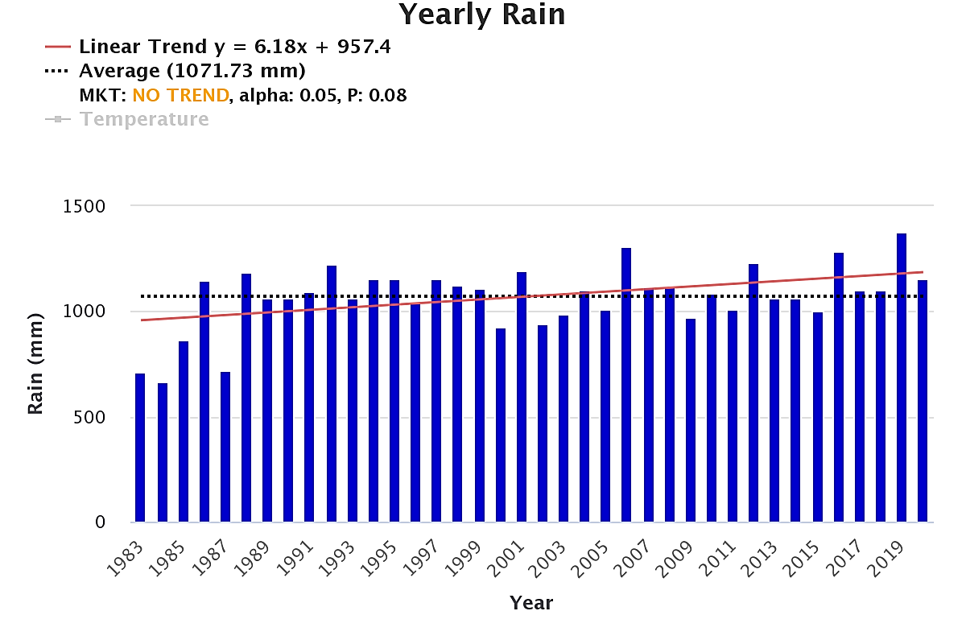

**Fig. 3** Annual Rainfall (1983–2019) distribution of Yola catchment area

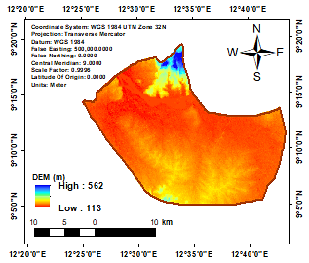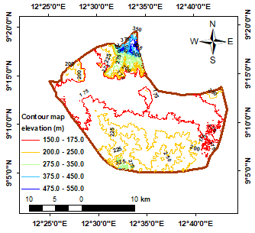 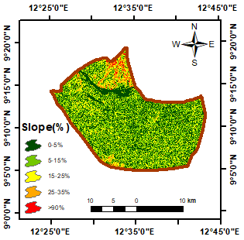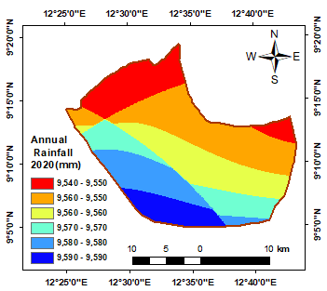 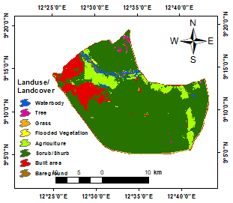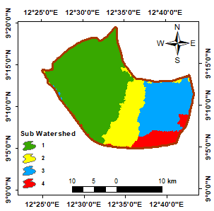

**a**

**e**

**f**

**d**

**c**

**b**

**Fig.3 (a)** Digital elevation model of the study area; **(b)** Contour map; **(c)** slope map **(d)** Rainfall **map (e)** LULC map

**(f)** Sub watershed map

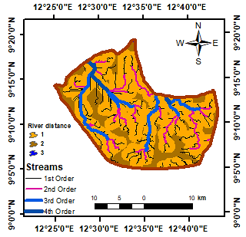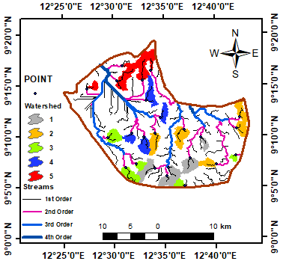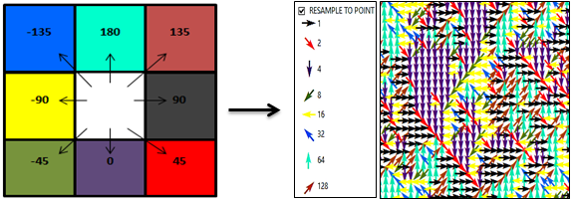

**a**

**b**

**c**

**Fig. 4 (a)** Stream network order map**; (b)** Basin Watershed **(c)** Flow direction matrix and direction coding

**3.8 Flow direction Matrix**

Each cell's flow direction is indicated by a value assigned by a direction flow grid. The topographical features determine the orientation of water movement within the cell. Depending on the direction of flow, this stage in hydrological modeling has varying significance. where the water eventually ends up as it travels across the terrain (MaDGIC, 2014). Grids for flow direction are made using the Flow Direction tool. Each set of nine cells, which is composed of a 3x3 grid, has an adjacent cell closest to the center that is determined by the grid processor. For every grid digit, if the central cell flows directly north, the value will correspond to a flow direction below. (**Figure 4c)** shows that if the direction is northeast, the value of 180 will decrease to 135. The elevation values from the underlying DEM are used to determine these numbers, which are only codes that define a particular directional value and have no numerical significance.

**4.0 Results and discussion**

**Table 2.** Most Flooodable and less Floodable villages within Yola cathment area

|  |  |  |  |
| --- | --- | --- | --- |
| **S/No** | **Most Floodable Villages** | **S/N Less Floodable Villages** |  |
| 1 | Rugange | 1. Modire | 10. Wuro Ardo kyari |
| 2 | Yolde Pate | 2. Takande | 11. Gaawi |
| 3 | Karewa 1 | 3 Bachure kofare | 12. Parda |
| 4 | Tature | 4 Karewa 2 | 13. Wuro Galadimawo |
| 5 | Wuro Mallum | 5. Yola | 14. Bati |
| 6 | Rumde Waziri | 6. Wuro hausa | 15. Bappawo |
| 7 | Lakare | 7. Lugere | 16. Njoboli |
| 8 | Rumde Kofa | 8. Sabore | 17. Gaita |
| 9 | Madumari | 9. Wuro boki | 18. Jalingo |
|  |  |  | 19. Yola |
|  |  |  | 20. Wuro hausa |
|  | Area= 170.6 km2 (33.3%) | Area= 130.1 km2  (25.41%) |  |

**4.1 Level Map**

DEM (SRTM) data was used to create the flood level map (Figures 5a & 5b) for the research area. Two flood levels were categorized using DEM, namely the more and least floodable areas. Floods can occur in the red zone, which is the floodable area that makes up 33.3% of the study area and covers an area of 170.6 km2, which affects nine (9) villages in the study area. The less floodable areas, which make up 25.41% of the study area and cover an area of 130.1 km2, affect twenty (20) villages in the study area.

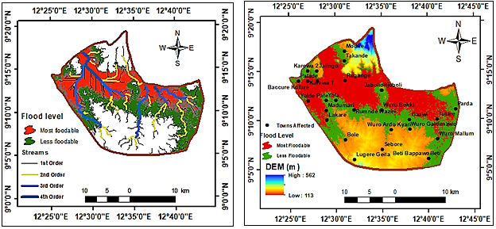**Fig. 5 (a)** Flood level with stream channels **(b)** flood level with locations and DEM

**a**

**b**

**5.0 Conclusion**

This research utilizes a single Digital Elevation Model (DEM) dataset derived from the Space Shuttle Radar Topography Mission (SRTM). Consequently, it invites researchers to explore alternative DEM sources, such as ASTER v.2 DEM, LiDAR-DEM, GLOBE DEM, and EARTHEnv-DEM90, to validate flood levels within the study region. The flood level map produced in this investigation (Figure 5b) illustrates the current flooding conditions of the area; the DEM was used to categorize flood levels into two groups - The less floodable areas, which make up 25.41% of the study area and the most floodable class covering 33.3% of the area offering essential insights for flood risk management. This information is crucial for prioritizing the development and assessment of regions at high risk. The study employs Geographic Information System (GIS) technology and remote sensing techniques to depict the recent flooding scenario and evaluate its impacts. It contributes to a deeper understanding of the flood event and serves as a reference for establishing effective flood management strategies, aiding governmental and organizational decision-making processes to reallocate resources for the benefit of affected populations. Furthermore, the findings may have significant implications for emergency preparedness, particularly in facilitating aid and relief efforts in vulnerable areas in the future. The generated map can assist relevant authorities in gaining a clearer understanding of the inundation patterns within floodplains, which fall under their jurisdiction for protection and mitigation. Additionally, it aims to enhance public awareness regarding flood imagery, thereby fostering a better understanding of flood risks.

**References**

[1] Adeagbo, A., Daramola, A., Carim-Sanni, A., Akujobi, C., & Ukpong, C. (2016). Effects of natural disasters on social and economic well-being: A study in Nigeria. Int. J. Disaster Risk Reduct. 17, 1–12.

[2] Adnan, S. G., & Kreibich, H. (2016). An evaluation of disaster risk reduction (DRR) approaches for coastal delta cities: a comparative analysis Natural Hazards 83:1257-1278

[3] Ahem, M., Kovats, R.S., Wilkinson, P., Few, R. & Matthies, F. (2005), “Global Health Impacts of Floods: Epidemiologic Evidence”. *Epidemiological Review*. 27 (1):36-46. doi: 10.1093/epirev/mxi00

[5] Bajabaa S., Masoud M., & Al-Amri, N. (2014). Flash flood hazard mapping based on quantitative  
hydrology, geomorphology and GIS techniques (case study of Wadi Al Lith, Saudi Arabia)  
Arabian Journal of Geosciences 7:2469-2481 doi:10.1007/s12517-013-0941-2

[6] Brammer, H. (1990) Floods in Bangladesh: I. Geographical background to the 1987 and 1988 floods Geographical Journal 156:12-22 doi:10.2307/635431

[7] Cai, T., Li, X.Y., Ding, X., Wang, J., & Zhan, J. (**2019**). Flood risk assessment based on hydrodynamic model and fuzzy comprehensive evaluation with GIS technique. *Int. J. Disaster Risk Reduct. 35*, 101077.

[8] Clark, M. J. (1998). Putting water in its place: A perspective on GIS in hydrology and water  
management. *Hydrological Processes,* Vol. 12, pp. 823–834.

[9] Digby, B., (1996). The Human Environment (Oxford: Heinemann).

[10] Dihn, Q., Balica, S., Popescu, I. & Jonoski, A. (2012). Climate change impact on flood vulnerability, vulnerability and risk of the Long Xuyen Quadrangle in the Mekong Delta. *International Journal River Basin Management.* ***10***, 103–120.

[11] Du J., Fang J., Xu W., & Shi P. (2013). Analysis of dry/wet conditions using the standardized precipitation index and its potential usefulness for drought/flood monitoring in Hunan Province China. Stoch Env Res Risk Assess 27(2):377–387

[12] Elnazer, A.A., Salman, S. A., & Asmoay A.S (2017). Flash flood hazard affected Ras Gharib city, Red Sea, Egypt: a proposed flash flood channel Natural Hazards 89:1389-1400 doi:10.1007/s11069- 017-3030-0

[13] Field, C.B., Barros. V., Stocker, T., F, & Dahe,Q. (2012). Managing the risks of extreme events and disasters to advance climate change adaptation: special report of the intergovernmental panel on climate change. Cambridge University Press.

[14] Garbrecht, J., & Martz, L. W., (1996). Digital landscape parameterization for hydrological applications. In Hydro GIS 96: Applications of Geographic Information Systems in Hydrology and Water Resources Management (Proceedings of the Vienna Conference, April 1996), IAHS Publication no. 235.

[15] Haris, I., Osborn., T.J & Jones, P. (2020). Version 4 of cru TS Monthly High-Resolution of gridded multivariate climate data set sci data 7. httpsP://doi.org/1038?s41597-020-0453-3

[16] IOM UN Migration (19th, July, 2022). Flood Incident: North-east Nigeria, Song LGA - Adamawa State Nigeria *DTM Nigeria****:*** [***https://displacement.iom.int/Nigeria***](http://word/https://displacement.iom.int/Nigeria)[***https://dtm.iom.int/nigeria***](http://word/https://dtm.iom.int/nigeria)

[17] Jonkman, S. N., & Kelman, I. (2005). An analysis of the causes and circumstances of flood disaster deaths. Disasters, 29, 75–97. https:// doi.org/10.1111/j.0361-3666.2005.00275.x

[18] Jonkman, S. N. & Dawson, R.J., (2012). Issues and challenges in flood risk management. *Editorial for the Special Issue on Flood Risk Management*. ***4***, 785–792

[19] Jarvis A., H.I. Reuter, A. Nelson, & E. Guevara, (2008). Hole-filled seamless SRTM data V4, International Centre for Tropical Agriculture (CIAT), available from [http://srtm.csi.cgiar.org](http://word/http://srtm.csi.cgiar.org).

[20] Karki,S., Shrestha, A., Bhattarai, M., & Thapa S. (2011). Gis Based Flood Hazard Mapping and Vulnerability Assessment of People Due to Climate Change: A Case Study from KANKAI Watershed, East Nepal.; doi:10.13140/2.1.4444.4962

[21] Khan, S. I., Hong, Y., Wang, J., Yilmaz, K. K., Gourley, J. J., Adler, and R.F.Irwin, D., (2011). Satellite remote sensing and hydrologic modeling for flood inundation mapping in Lake Victoria basin: Implications for hydrologic prediction in ungagged basins. *IEEE Transportation Geoscience Remote Sensing.* ***49***, 85–95.

[22] Khan, H., Haider, S., Saeed, K., & Ali N. (2008). Assessment of potable water quality of Kohat division and its impact on health. J Chem Soc Pak 30:246–250

[23] Leopold, L.B., Wolman, M.G & Miller, J.P. (2012.) Fluvial Processes in Geomorphology; Courier Corporation: Chelmsford, MA, USA

[24] Lyu, H.-M., Shen, S.-L., Zhou, A. &Yang, J. (2019). Perspectives for flood risk assessment and management for mega-city metro system. *Tunn. Undergr. Space Technol.*, *84*, 31–44.

[25] McCarthy, J.J., (2001). Climate Change 2001: Impacts, Adaptation, and Vulnerability:  
Contribution of Working Group II to the Third Assessment Report of the  
Intergovernmental Panel on Climate Change. Cambridge University Press,  
Cambridge, UK.

[26] MISNA-Missionary International Service News Agency (2012). Floods from North to South, Alarm for Crops,” http://reliefweb.int/report/nigeria/floods-north-south-alarm-crops

[27] Ojigi, M. L., Abdulkadir, F. I. & Aderoju, M. O. (2013). Geospatial Mapping and Analysis of the 2012 Flood Disaster in Central Parts of Nigeria. *8th National GIS Symposium. Dammam. Saudi Arabia.* April 15-17, 2013*.*

[28] Petit-Boix, A., Sevigne-Itoiz, E., Rojas-Gutierrez, L.A., Barbassa, A.P., Josa, A., Rieradevall, J.,& Gabarrell, X. (2017). Floods and consequential life cycle assessment: Integrating flood damage into the environmental assessment of stormwater Best Management Practices. *J. Clean. Prod.*, *162*, 601–608.

[29] Rahman, M., Di, L., Yu, E., Lin, L., Zhang, C, & Tang J. (2019). Rapid flood progress monitoring in cropland with NASA SMAP Remote Sensing 11:191

[30] Reuter, H.I., A. Nelson, A. Jarvis. (2007). An evaluation of void filling interpolation methods for SRTM data, International Journal of Geographic ([http://srtm.csi.cgiar.org](http://word/http://srtm.csi.cgiar.org)).

[31] Patel, D.P, & Srivastava, P.K. (2013). Flood hazards mitigation analysis using remote sensing and GIS: correspondence with town planning scheme. Water Resour Manag 27:2353–2368

[32] Pourghasemi, H.R., Moradi, H.R., Aghda, S.M.F., Gokceoglu, C., & Pradhan, B. (2014) GIS-based landslide susceptibility mapping with probabilistic likelihood ratio and spatial multi-criteria evaluation models (North of Tehran, Iran). Arab J Geosci 7(5):1857–1878

[33] Pradhan, B. (2010). Flood susceptible mapping and risk area delineation using logistic regression, GIS and remote sensing. J Spatial Hydrol 9:1–18

[34] Sebastian, A. S., & Adetola, S. O. (2022). Application of Remote Sensing and GIS-Weighted overlay Method for Mapping of Groundwater Potential in Michika NE Nigeria. *57TH NMGS Annual International Conference and Exhibition Garden City Port Harcourt Nigeria:* Theme Environmental Sustainability Nigerian Mining and Geoscience society (NMGS): NMGS Publication. Vol. 3 Pp, 416-428

[35] Sun, R., Gong, Z., Gao, G., & Shah, A.A. (2020) Comparative analysis of Multi-Criteria Decision-Making methods for flood disaster risk in the Yangtze River Delta. *Int. J. Disaster Risk Reduct.51*, 101768.

[36] Tehrany, M.S.; Pradhan, B.; Mansor, S & Ahmad, N. (2015). Flood susceptibility assessment using GIS-based support vector machine model with different kernel types. *Catena 125*, 91–101

[37] United Nations International Strategy for Disaster Relief, 2011. Revealing Risk, Redefining  
Development. Geneva.

[38] United Nations Office for Disaster Risk Reduction (UNISDR). (2004). *Living with risk: a global review of disaster reduction initiatives.* 429 p

[39] Yalcin, G.,& Akyurek, Z. (2004). Analysing flood vulnerable areas with multicriteria evaluation. In Youssef AM, Pradhan B, Hassan AM (2011) Flash flood risk estimation along the St.Katherine road, southern Sinai, Egypt using GIS based morphometry and satellite imagery. Environ Earth Sci 62:611–623

[40] WHO. (2003). World Health Organization. Disaster Data-key Trends and Statistics in World Disasters Report WHO:Geneva, Switzerland En.pdf (Accessed 5 April 2017) [http://www.ifrc.org/PageFiles/89755/2003/43800-WDR2003](http://word/http://www.ifrc.org/PageFiles/89755/2003/43800-WDR2003)

[41] Saha, A.K., Gupta RP, Sarkar I, Arora K.M, Csaplovics, E. (2005. An approach for GIS-based statistical landslide susceptibility zonation with a case study in the Himalayas. Landslides 2(1):61–69

[42] Wang, H.B., Wu, S.R., Shi, J.S, & Li, B. (2013) Qualitative hazard and risk assessment of landslides: a practical framework for a case study in China. Nat Hazard 69(3):1281–1294